

St Helen’s Church of England
Primary School


Mathematics Policy

Shine Curriculum Intent
At St Helens CE Primary School, we envision a future where all children shine brightly, achieving their full potential and making positive contributions to society through our high-quality, progressive curriculum and nurturing Christian values. Through our knowledge-rich approach and commitment to equality and diversity, we inspire confident, inquisitive learners who are prepared for life's challenges with love and support.

Shine Curriculum Values

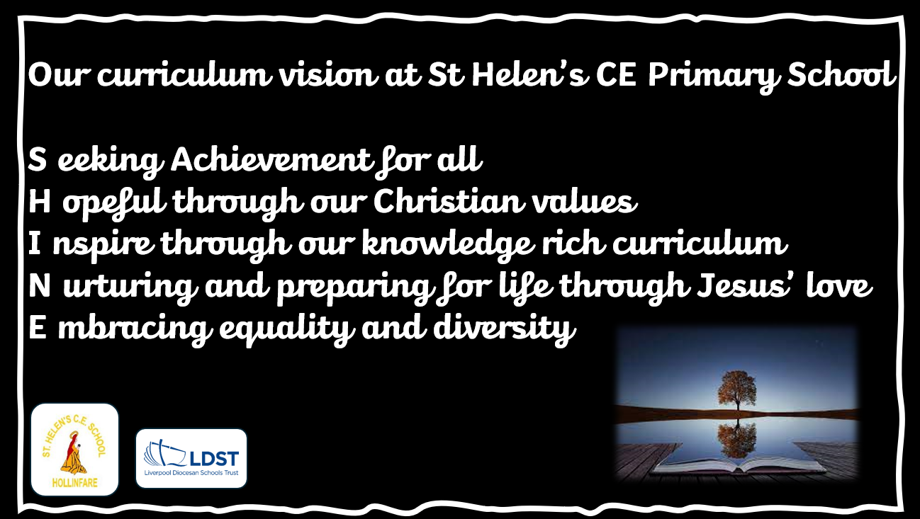

Seeking achievement for all.

At St Helens CE Primary, we aspire for all children to succeed, achieve and flourish, embracing a high-quality, progressive curriculum. Our students will make positive contributions to the school, society and the world, fostering curiosity and a thirst for knowledge.
Hopeful, through our Christian Values.
At St Helens CE Primary, we empower children with Christian values and biblical teachings to support their families, friends, and community, inspiring them to make a positive impact in the world they live in.

Inspire, through our knowledge-rich curriculum.
At St Helens CE Primary, we are dedicated to provide a knowledge-rich curriculum that empowers all children to become confident, inquisitive, and independent learners. Our sequenced and planned approach ensures that every child leaves our school with a vast knowledge across all subjects, setting them up for success in their academic and personal journeys.


Nurturing and preparing for life, through Jesus’ love.
At St Helens CE Primary, we strive to empower every child to reach their full potential by nurturing them with our Christian values. Through our SHINE enrichment programme, we provide opportunities for personal development, equipping our students with cultural capital and essential life skills. Our vision is to create a community where every child can shine brightly and make a positive impact on the world around them.

Embracing equality and diversity.

At St Helens CE Primary, we believe in the inherent potential of every child to achieve and succeed. We foster a culture where each student is valued as a unique individual, treated with dignity, respect and kindness. Our vision is to create a nurturing and inclusive environment that empowers students to flourish academically, socially, and emotionally, preparing them to positively impact their community and the world.

Curriculum Implementation

Teaching Expectations
Mathematics at Foundation Stage is covered in the mathematics strand of the EYFS Curriculum and is taught at St Helens’ CE Primary using the NCETM Mastery in Number that is supplemented with White Rose Maths for shape and measurement and based on the ‘Development Matters’ guidance. Maths is taught daily in all classes.

5 a day maths
Alongside mathematics lessons, children have the opportunity to develop their number sense. This may take the form of developing number fluency by exploring the relationship between numbers. In addition, it allows classes to revisit key mathematical learning through practising questions from the ‘5 a day’ section. This is also used to practise arithmetic.

Structure of lessons:
In Early Years Foundation Stage, maths will be taught through adult directed activities enabling children to initiate their own learning in the Early Years Foundation Stage environment.

A typical lesson in years 1-6 will include:
• Get Ready – An opportunity to explore and revisit previous learning
• Let’s Learn – Children will explore new mathematical concepts using the CPA approach and an opportunity to discuss and journal their new learning in their maths books
• Your turn – Children can continue to explore and practise what they have been taught with support and then continue independently in their workbooks

In years 1 and 2 children will explore journaling an initial mathematical problem using a range of concrete apparatus and exploring a variety of mathematical models and images to find their most efficient method. It must be noted that where topics do not align for mixed year groups, lessons are to be taught using isolated objectives. However, where lessons can be taught alongside each other, the different objectives are extended for the higher year group. This may alter the lesson structure slightly while children are given separate learning inputs by the class teacher, however the lesson format should be as closely aligned as possible.
Staff will check students learning at key points throughout the lesson and misconceptions will be addressed as they arise. As a result, children will develop their mathematical fluency, problem solving and reasoning. See appendix for lesson plan structure template. Variation within the lesson may be shown through children’s outcomes, use of resources, methods used, progression through CPA approach, addressing the concept being taught through varied fluency, problem solving and reasoning.

Working walls
Year 1-6 classrooms have a working wall which reflects current mathematical learning. It identifies key mathematical representations to support children conceptual understanding and age-appropriate models and images following the CPA approach. Key vocabulary is also identified alongside mathematical sentence stems to support children in verbalising and understanding further what they have learnt and understood. It also displays children’s 5-a-day maths questions.

EYFS has a maths station in which they can show and explore concepts of number. This will be supported by quality concrete resources and a selection of books related to number including number rhymes and stories.

Presentation in books
In all lessons learning objectives are created as ‘I can’ statements which are used to mark learning against. A short date at the top of the page should be underlined. Children should be encouraged to take pride in their work and cross out mistakes neatly with a line. Children will use a ruler to draw lines throughout their work. Where children do their own sticking in, this should be done neatly and with care.

Feedback from learning
Marking of children’s work is essential to ensure they make further progress. Work is marked in line with the school feedback and making policy. Children should be given time to respond to teacher feedback and correction of mistakes at the earliest opportunity and in purple pen. This may be achieved through live marking to allow addressing of misconceptions as they arise. Some work in mathematics can be marked by children themselves with support and guidance from the teacher. Teachers will initial self/peer marked work to show they have identified whether further feedback may or may not be needed. Teachers use of highlighters will indicate to children their success and where further support is needed.

Assessment
Assessment through formative assessment throughout the maths lessons and marking of books. This will be used to support and identify specific areas that children need to develop. This knowledge will then impact on the daily planning of lessons to support and develop these specific areas.

Summative assessments will also be given as detailed in the school yearly assessment cycle. Years 2 and 6 will complete year group specific test papers and years 1, 3, 4 and 5 complete NFER tests. These results will be placed on ‘ATLAS’ which will give each class teacher a closer question analysis to support learning and identifying next steps.

The development of the lesson ensures that all children have the opportunity at working within the expected level and greater depth. The impact of the maths lesson will ensure that all children make good progress from their starting point. This will be shown at the end of key stage tests where progress and attainment are shown to be above national standards.

Impact

• Become fluent in the fundamentals of mathematics, including through varied and frequent practice with increasingly complex problems over time, so that pupils develop conceptual understanding and the ability to recall and apply knowledge rapidly and accurately
• Reason mathematically by following a line of enquiry, conjecturing relationships and generalisations, and developing an argument, justification, or proof using mathematical language
• Can solve problems by applying their mathematics to a variety of routine and non-routine problems with increasing sophistication, including breaking down problems into a series of simpler steps and persevering in seeking solutions.

Appendices

TA/Teacher Proforma.

Lesson: Maths Teacher:
Date: Class:
L.O:
Task:

Resources:
Maths manipulatives and models to support learning in the lesson

Get Ready
An opportunity to explore and revisit previous learning
Key questions
What are the misconceptions? Exploration
What key models, images and manipulatives support review of learning?

Let’s Learn:
Children will explore new mathematical concepts using the CPA approach and an opportunity to discuss and journal their new learning in their maths books.
Exploration through CPA approach Journalling
Sharing methods
Discussions and key questions
Show me? Make the numbers? What does the red represent? What are the misconceptions?
Encourage full use of full sentences

Examples of feedback questions to support learning
How could you sort these?
How many ways can you find to?
What happens when we?
What can be made from?
How many different can be found?
Have we found all the possibilities? How do we know?
Have you thought of another way this could be done? Do you think we have found the best solution?

